Idea of this project create API what can work from Postman with different types request and showing information from file, and save information to files (requests to Google API and work with S3 files), delete files from S3

***Python-Project.ipynb***

1. Block functions.py
2. Block lambda-function.py
3. JSON request
4. Automatic tests

***Test plan.docx*** - test plan for automatic tests for Block 4 in Python-Project.ipynb

***Test AWS.docx*** - tests with requests in AWS

***Test from Postman.docx*** - tests with requests in Postman

***API documentation*** - <https://documenter.getpostman.com/view/32364662/2sA2xe5EUv>

***Project-backend-only.ipynb*** - example work for backend only

***project.zip*** - zip-file for download project to AWS

***Role in AWS***

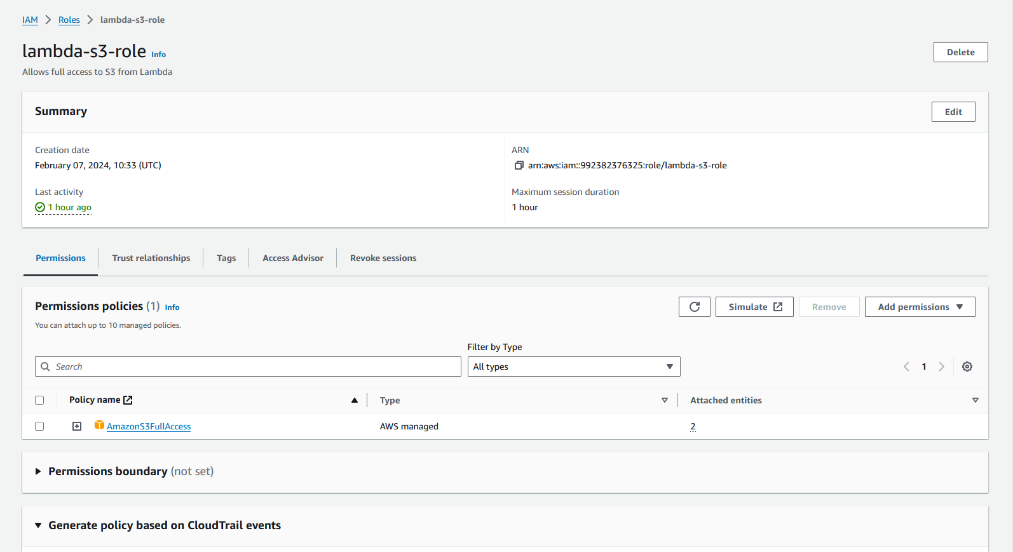

***Vulnerabilities and cybersecurity concerns.docx*** - Cyber Security concerns step-by-step